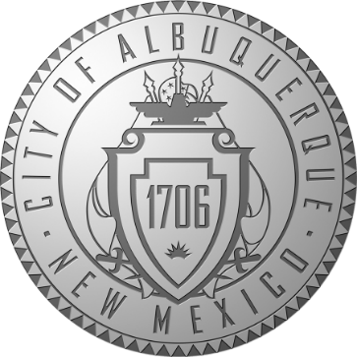

CITY OF ALBUQUERQUE DEPARTMENT OF MUNICIPAL DEVELOPMENT

**CITYWIDE ON-CALL ENGINEERING SERVICES FOR TRANSPORTATION AND STORM DRAINAGE**

Project Numbers: 138.02

# SCOPE OF PROJECTS

**Engineering Projects May Include But Are Not Limited to the Following: Study Phase Services**

* Green Stormwater Infrastructure (GSI) Evaluations
* Determine opportunities for GSI in Transportation and Drainage projects or GSI stand-alone projects.
* Roadway Evaluations
  + Background Data Collection/As-Built Review
* Drainage Evaluations
  + Hydraulic/Hydrologic Analyses, Floodplain Delineation and Mapping
  + Review of site conditions and existing drainage reports
* Traffic Analysis
  + Signal Warrant Analyses
* Public Meetings

# Design Phase Services

* Roadway Design
  + Bicycle Facility Implementation, Complete Streets Design, PROWAG Implementation
* Storm Drain Design
  + Storm Pipe Network Design, LID implementation, Surface Flow Conveyance
* Traffic Design
  + Traffic Signal Design, Corridor Timing Development, ITS, Vehicle/Bicycle Detection
* Pump Station Rehabilitation and Evaluation
  + Motor, pump and electronic design and evaluation
  + Pump station operation design
  + Analysis of pump station facilities
* GSI Infrastructure
  + GSI design including landscape design
  + Building community support and incorporating concerns/ideas.
* DRC Submittals
* Public Meetings

# Federal Funding / Certifications

* Environmental Investigations, Cultural Studies, Utility Certification, Railroad Certification, ROW Certification, Intelligent Transportation System Certification

# Bidding and Construction Phase Services

* Plans Set Creation
* Knowledge and implementation of City, State, and National Standard Specifications
* Estimates
* Construction Contract Documents (City and Federal)
* Construction Meetings
* Construction Management
  + B2GNow and LCP Tracker
  + Daily Construction Logs
* RFI Review
* Record Drawing Creation

# STANDARD GUIDELINES

* City of Albuquerque Development Process Manual
* City of Albuquerque Specifications and Standard Drawings
* City of Albuquerque Complete Streets Ordinance
* Public Right of Way Accessibility Guidelines (PROWAG)
* Manual on Uniform Traffic Control Devices (MUTCD)
* American Association of State Highway and Transportation (AASHTO)
* National Association of City Transportation Officials (NACTO)
* Highway Capacity Manual (HCM)

# CONTRACT INFORMATION

* Not to exceed 3 years
* Not to exceed $1,000,000

# EXPECTATIONS

**For Contract**

* Quick Responses
* Time Management
* Task Management
* Project Coordination
* Federal Funding Reimbursement Requirements
* Progress Billings

# For Proposal

* Detailed Team Member Experience
* Detailed Firm On-Call Experience
* Follow advertisement guidelines exactly
* Proposals Due **Tuesday, May 20th, 2020 until 3 PM.** Please note that the City of Albuquerque is open for business and will be accepting proposals electronically. Send your proposals to [**myrnamarquez@cabq.gov**](mailto:myrnamarquez@cabq.gov) by the deadline noted. ***For now, a copy of your general and professional liability insurance coverage is acceptable in lieu of the notary stamp.*** In order to assure your proposal is delivered, make sure it is 5MB or less and is in PDF format. Thank you and stay safe!